21.74: a) 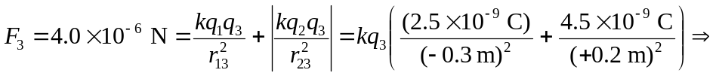
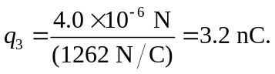
b) The force acts on the middle charge to the right.
c) The force equals zero if the two forces from the other charges cancel. Because of the magnitude and size of the charges, this can only occur to the left of the negative charge 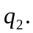 Then: 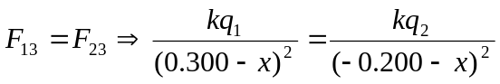where is the distance from the origin. Solving for we find: 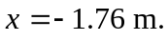 The other value of was between the two charges and is not allowed.

